RESOLUTION NO.__________

RE: CERTIFICATE OF APPROPRIATENESS UNDER THE
PROVISIONS OF THE ACT OF THE PENNSYLVANIA
LEGISLATURE 1961, JUNE 13, P.L. 282 (53
SECTION 8004) AND BETHLEHEM ORDINANCE NO.
3952 AS AMENDED.

WHEREAS, it is proposed to build an addition on the rear of this single family residential structure at 208 E. Fourth St.

NOW, THEREFORE, BE IT RESOLVED by the Council of the City of Bethlehem that a Certificate of Appropriateness is hereby granted for the work.

Sponsored by: (s)

(s)

ADOPTED BY COUNCIL THIS DAY OF

(s)
President of Council

ATTEST:

(s)
City Clerk

HISTORIC CONSERVATION COMMISSION

CASE # 525 – It is proposed to build an addition on the rear portion of this single family residential structure at 208 E. Fourth St.
OWNER/APPLICANT: Webster Street Holdings, LLC / James Byszewski & Louis Intile

The Commission upon motion by Mr. Lader seconded by Ms. Starbuck adopted the proposal that City Council issue a Certificate of Appropriateness for the proposed work described herein:

- The proposal to build an addition on the rear portion of this single family residential structure at 208 E. Fourth St. was presented by James Byszewski & Louis Intile.
- Roof edges will be added to follow the original roof lines on the rear third story addition to the main section of the house. Similar built out roof edges will be added to the three story rear addition to house to help reduce the scale of the addition.
- The third floor egress window planned for the west elevation will be moved to the south elevation as discussed at the meeting, and a new window will be added to the south elevation of the new addition on the third floor.
- Because of limited visibility, the rear addition will be sided with 4” CertainTeed Main Street vinyl siding in a warm neutral color.
- The existing roof and new addition roof will be GAF Slateline in Antique Slate or CertainTeed Hatteras in a similar slate gray color.
- Because the rear section of the house did not originally have shutters it was recommended to delete the proposed shutters.
- The existing vinyl windows in the house and the new windows in the addition will be Harvey Slimline (or equivalent), white vinyl, double hung windows with half screen, and no grids. Casement style windows with single horizontal muntins will be used for egress windows if necessary. Vinyl windows were approved for the addition due to its limited visibility at the rear of the property.
- The new windows in the new additions will have 3” casings.
- The original front railings belonging to the house have been discovered and will be restored if possible.
- The existing siding will be painted to match the new in color
- Revised drawings were requested to be approved by the Historic Officer.

- The proposed motion was unanimously approved.

CU: cu
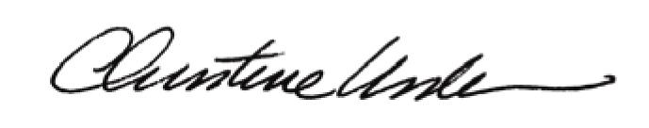
By:

Date of Meeting: November 17, 2014 Title: Historic Officer

